==================================================

Running Genetic Algorithm...

==================================================

==================================================

=== GENETIC ALGORITHM OPTIMIZATION ===

==================================================

[Initialization]

- Population size: 30

- Generations: 20

- Crossover rate: 80%

- Mutation rate: 20%

- Search space: 176 features

- Target: Minimize MSE using CatBoost

==================================================

=== OPTIMIZATION RESULTS ===

==================================================

▶ Best MSE achieved: 12838.393577

▶ Time elapsed: 409.59 seconds

▶ Features selected: 100/176 (43.2% reduction)

▶ Selected features:

1. District

2. Neighborhood

3. m² (Gross)

4. m² (Net)

5. Number of rooms

6. Building Age

7. Floor location

8. Heating

9. Number of bathrooms

10. Furnished

11. Using status

12. Available for Loan

13. From who

14. Swap

15. Front West

16. Front South

17. Alarm (Thief)

18. Alaturka Toilet

19. American Door

20. Elevator

21. Painted

22. Refrigerator

23. Fiber Internet

24. Dressing room

25. Intercom System

26. Insulating glass

27. Air conditioning

28. Tub

29. Laminate Floor

30. Marley

31. Furniture

32. Kitchen (Built-in)

33. Kitchen (Laminate)

34. PVC Joinery

35. Blinds

36. Set Top Cooker

37. Spot Lighting

38. Thermosiphon

39. Cloakroom

40. Wi-Fi

41. Face Recognition & Fingerprint

42. Washing machine

43. Laundry room

44. Water heater

45. Fireplace

46. Elevator.1

47. Security

48. Bath

49. Booster

50. Thermal Insulation

51. Generator

52. Cable TV

53. Closed Garage

54. Playground

55. Sports Area

56. Water tank

57. Tennis court

58. Satellite

59. Fire escape

60. Swimming Pool (Open)

61. Swimming Pool (Indoor)

62. Parking Lot

63. Bathroom

64. Wide Corridor

65. Entrance / Ramp

66. Kitchen

67. Handle / Railing

68. municipality

69. Cemevi

70. Next to sea shore

71. Fair

72. Hospital

73. Synagogue

74. Park.1

75. Gym

76. Unirsity

77. Highway

78. Bosphorus Bridges

79. Sea bus

80. Filled

81. Marmaray

82. Minibus

83. Bus stop

84. Coast

85. Tram

86. Railway station

87. Trolley bus

88. Scaffolding

89. Lake

90. Pool

91. City

92. Mezzanine Duplex

93. Garden Duplex

94. Garden Floor

95. Top floor

96. Entrance floor

97. Floor Duplex

98. Private Entry

99. Rerse Duplex

100. Roof Duplex

▶ Convergence progress:

- Initial MSE: 13375.4973

- Final MSE: 12863.7715

- Improvement: 3.8%

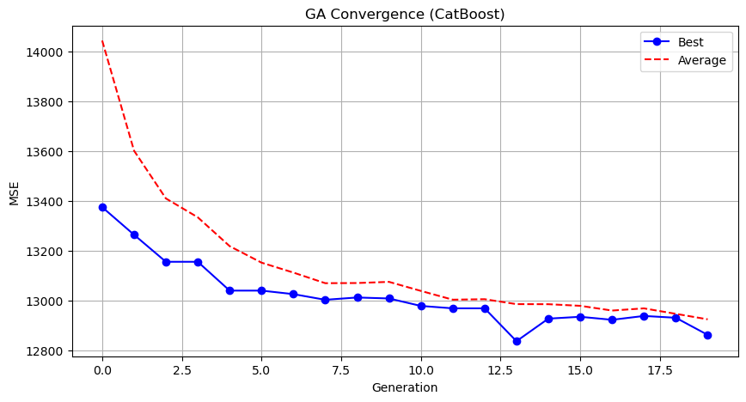

Genetic Algorithm completed successfully with MSE: 12838.3936

==================================================

Running Particle Swarm Optimization...

==================================================

==================================================

=== PARTICLE SWARM OPTIMIZATION ===

==================================================

[Initialization]

- Swarm size: 30 particles

- Iterations: 20

- Cognitive weight: 0.5

- Social weight: 0.5

- Inertia weight: 0.5

- Search space: 176 features

- Target: Minimize MSE using CatBoost

==================================================

=== OPTIMIZATION RESULTS ===

==================================================

▶ Best MSE achieved: 12954.850829

▶ Time elapsed: 426.86 seconds

▶ Features selected: 94/176 (46.6% reduction)

▶ Selected features (with weights):

1. District (weight: 0.592)

2. Neighborhood (weight: 0.536)

3. m² (Gross) (weight: 1.000)

4. Number of rooms (weight: 0.557)

5. Building Age (weight: 0.518)

6. Floor location (weight: 0.560)

7. Number of floors (weight: 0.783)

8. Number of bathrooms (weight: 0.774)

9. Furnished (weight: 0.670)

10. Available for Loan (weight: 0.575)

11. Swap (weight: 0.545)

12. Front South (weight: 0.536)

13. Front North (weight: 0.884)

14. Alarm (Thief) (weight: 0.641)

15. Alarm (Fire) (weight: 0.903)

16. Elevator (weight: 0.687)

17. Balcony.1 (weight: 0.643)

18. Barbecue (weight: 0.884)

19. Household appliances (weight: 0.605)

20. Dishwasher (weight: 0.621)

21. Refrigerator (weight: 0.798)

22. Wall paper (weight: 0.785)

23. Fiber Internet (weight: 0.674)

24. Video intercom (weight: 0.692)

25. Intercom System (weight: 0.773)

26. Insulating glass (weight: 0.720)

27. Plasterboard (weight: 0.706)

28. Cellar (weight: 0.793)

29. Tub (weight: 0.759)

30. Laminate Floor (weight: 0.593)

31. Kitchen (Built-in) (weight: 0.601)

32. Kitchen Natural Gas (weight: 0.660)

33. Blinds (weight: 0.758)

34. Terrace (weight: 0.743)

35. Thermosiphon (weight: 0.552)

36. Washing Machine (weight: 0.930)

37. Washing machine (weight: 0.817)

38. Steel door (weight: 0.572)

39. Fireplace (weight: 0.957)

40. Elevator.1 (weight: 0.566)

41. Security (weight: 0.542)

42. Bath (weight: 0.750)

43. Thermal Insulation (weight: 0.795)

44. Generator (weight: 0.770)

45. Cable TV (weight: 0.855)

46. Nursery (weight: 0.790)

47. Car park (weight: 0.786)

48. Playground (weight: 0.593)

49. Sound insulation (weight: 0.736)

50. Sports Area (weight: 0.820)

51. Water tank (weight: 0.622)

52. Fire escape (weight: 0.649)

53. Swimming Pool (Open) (weight: 0.840)

54. Parking Lot (weight: 0.789)

55. Elevator.2 (weight: 0.586)

56. Wide Corridor (weight: 0.793)

57. Stairs (weight: 0.952)

58. Kitchen (weight: 0.728)

59. Room door (weight: 0.519)

60. Socket / Electric Switch (weight: 0.644)

61. Swimming pool (weight: 0.699)

62. municipality (weight: 0.720)

63. Next to sea shore (weight: 0.588)

64. Fair (weight: 0.699)

65. Hospital (weight: 0.516)

66. Synagogue (weight: 0.694)

67. The church (weight: 0.670)

68. High school (weight: 0.512)

69. Park.1 (weight: 0.922)

70. The health clinic (weight: 0.524)

71. Gym (weight: 1.000)

72. Primary School-Secondary School (weight: 0.580)

73. Bosphorus Bridges (weight: 0.741)

74. Street (weight: 0.574)

75. Sea bus (weight: 0.593)

76. E-5 (weight: 0.888)

77. Metro (weight: 0.825)

78. Metrobus (weight: 0.552)

79. Bus stop (weight: 0.775)

80. TEM (weight: 0.581)

81. Cable car (weight: 0.739)

82. Tram (weight: 0.696)

83. Trolley bus (weight: 0.781)

84. Scaffolding (weight: 0.518)

85. Throat (weight: 0.965)

86. Sea (weight: 0.910)

87. Pool (weight: 0.973)

88. Mezzanine (weight: 0.913)

89. Mezzanine Duplex (weight: 0.765)

90. Garden Duplex (weight: 0.770)

91. Garden Floor (weight: 0.955)

92. Garage / Shop Top (weight: 0.773)

93. Rerse Duplex (weight: 0.779)

94. Ground floor (weight: 0.765)

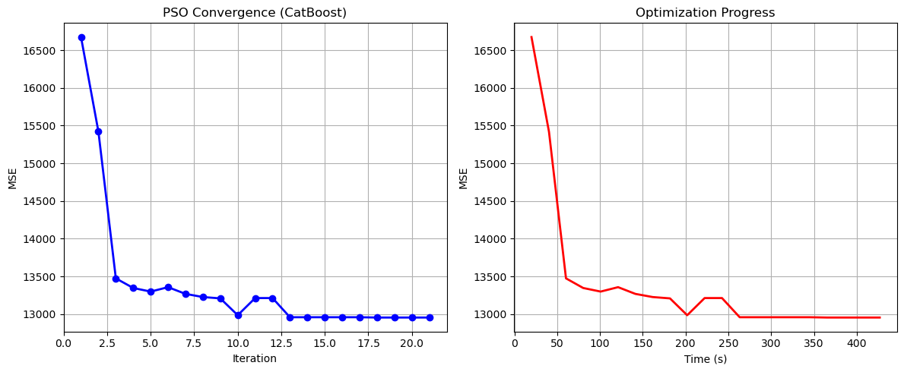

Particle Swarm Optimization completed successfully with MSE: 12954.8508

==================================================

Running Whale Optimization...

==================================================

==================================================

=== WHALE OPTIMIZATION ALGORITHM ===

==================================================

[Initialization]

- Population: 30 whales

- Max iterations: 20

- Spiral coefficient (b): 1.0

- Search space: 176 features

- Target: Minimize MSE using CatBoost

[Optimization Progress]

Iter 20/20 | Best MSE: 12915.017880

==================================================

=== OPTIMIZATION RESULTS ===

==================================================

▶ Best MSE achieved: 12915.017880

▶ Time elapsed: 416.14 seconds

▶ Features selected: 169/176 (4.0% reduction)

▶ Selected features:

1. District

2. Neighborhood

3. m² (Gross)

4. m² (Net)

5. Number of rooms

6. Building Age

7. Floor location

8. Number of floors

9. Heating

10. Number of bathrooms

11. Balcony

12. Furnished

13. Using status

14. Available for Loan

15. From who

16. Swap

17. Front West

18. Front East

19. Front South

20. Front North

21. ADSL

22. Wood Joinery

23. Smart House

24. Alarm (Thief)

25. Alarm (Fire)

26. Alaturka Toilet

27. Aluminum joinery

28. American Door

29. American kitchen

30. Built-in on

31. Elevator

32. Balcony.1

33. Barbecue

34. Household appliances

35. Painted

36. Dishwasher

37. Refrigerator

38. Wall paper

39. Shower

40. Parents' Bathroom

41. Fiber Internet

42. On

43. Dressing room

44. Closet

45. Video intercom

46. Hilton Bathroom

47. Intercom System

48. Insulating glass

49. Jacuzzi

50. Plasterboard

51. Cellar

52. Air conditioning

53. Tub

54. Laminate Floor

55. Marley

56. Furniture

57. Kitchen (Built-in)

58. Kitchen (Laminate)

59. Kitchen Natural Gas

60. PVC Joinery

61. Blinds

62. Parquet Floor

63. Ceramic Floor

64. Set Top Cooker

65. Spot Lighting

66. Terrace

67. Thermosiphon

68. Cloakroom

69. Wi-Fi

70. Face Recognition & Fingerprint

71. Washing Machine

72. Washing machine

73. Laundry room

74. Steel door

75. Water heater

76. Fireplace

77. Elevator.1

78. Steam room

79. Security

80. Bath

81. Booster

82. Thermal Insulation

83. Generator

84. Cable TV

85. Closed Garage

86. Doorman

87. Nursery

88. Car park

89. Playground

90. Sauna

91. Sound insulation

92. Siding

93. Sports Area

94. Water tank

95. Tennis court

96. Satellite

97. Fire escape

98. Swimming Pool (Open)

99. Swimming Pool (Indoor)

100. Parking Lot

101. Elevator.2

102. Bathroom

103. Wide Corridor

104. Entrance / Ramp

105. Stairs

106. Kitchen

107. Room door

108. Socket / Electric Switch

109. Toilet

110. Swimming pool

111. The mall

112. municipality

113. Mosque

114. Cemevi

115. Next to sea shore

116. Pharmacy

117. Amusement center

118. Fair

119. Hospital

120. Synagogue

121. The church

122. Market

123. Park.1

124. The health clinic

125. District Market

126. Gym

127. Unirsity

128. Primary School-Secondary School

129. Fire Department

130. Town center

131. Highway

132. Eurasia Tunnel

133. Bosphorus Bridges

134. Street

135. Sea bus

136. Filled

137. E-5

138. Marmaray

139. Metro

140. Metrobus

141. Minibus

142. Coast

143. TEM

144. Cable car

145. Tram

146. Railway station

147. Trolley bus

148. Scaffolding

149. Throat

150. Sea

151. Nature

152. Lake

153. Pool

154. Park & ​​Green Area

155. City

156. Mezzanine

157. Mezzanine Duplex

158. Garden Duplex

159. Garden Floor

160. Garden

161. Top floor

162. Garage / Shop Top

163. Entrance floor

164. Floor Duplex

165. Private Entry

166. Rerse Duplex

167. Triplex

168. Ground floor

169. Roof Duplex

▶ Convergence progress:

- Initial MSE: 15139.4901

- Final MSE: 13015.8926

- Improvement: 14.0%

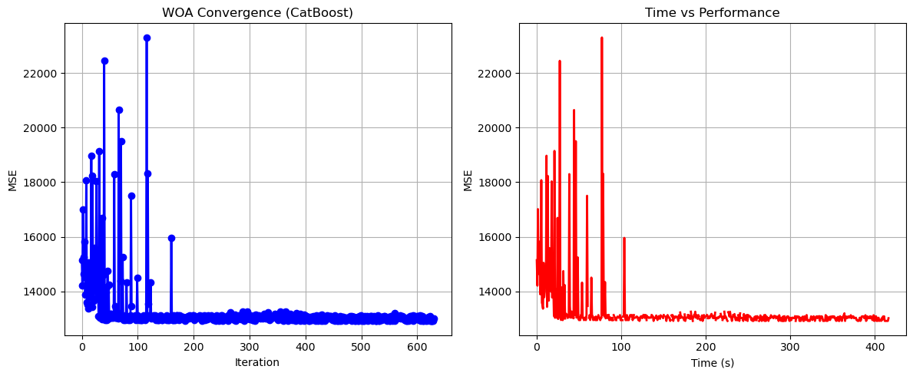

Whale Optimization completed successfully with MSE: 12915.0179

==================================================

Running Squid Game Optimizer...

==================================================

==================================================

=== SQUID GAME OPTIMIZER (SGO) ===

==================================================

[Initialization]

- Players: 30 (15 offensive, 15 defensive)

- Max games: 20

- Search space: 176 features

- Target: Minimize MSE using CatBoost

==================================================

=== OPTIMIZATION RESULTS ===

==================================================

▶ Best MSE achieved: 12911.941223

▶ Time elapsed: 420.82 seconds

▶ Features selected: 74/176 (58.0% reduction)

▶ Selected features:

1. District

2. m² (Gross)

3. m² (Net)

4. Number of rooms

5. Floor location

6. Number of floors

7. Heating

8. Number of bathrooms

9. Available for Loan

10. Swap

11. Smart House

12. Alarm (Thief)

13. Barbecue

14. Household appliances

15. Painted

16. Dishwasher

17. Refrigerator

18. Video intercom

19. Intercom System

20. Insulating glass

21. Cellar

22. Air conditioning

23. Tub

24. Laminate Floor

25. Furniture

26. Kitchen (Built-in)

27. Blinds

28. Parquet Floor

29. Thermosiphon

30. Wi-Fi

31. Washing Machine

32. Fireplace

33. Elevator.1

34. Security

35. Bath

36. Thermal Insulation

37. Generator

38. Closed Garage

39. With Private Pool

40. Sound insulation

41. Siding

42. Fire escape

43. Swimming Pool (Open)

44. Swimming Pool (Indoor)

45. Wide Corridor

46. Entrance / Ramp

47. Stairs

48. Kitchen

49. Park

50. Swimming pool

51. municipality

52. Amusement center

53. Market

54. Police station

55. Highway

56. Bosphorus Bridges

57. Sea bus

58. Airport

59. Metrobus

60. Bus stop

61. Coast

62. TEM

63. Tram

64. Railway station

65. Scaffolding

66. Throat

67. Sea

68. Lake

69. Pool

70. Garden Duplex

71. Top floor

72. Private Entry

73. Rerse Duplex

74. Roof Duplex

▶ Convergence progress:

- Initial MSE: 13146.5779

- Final MSE: 12911.9412

- Improvement: 1.8%

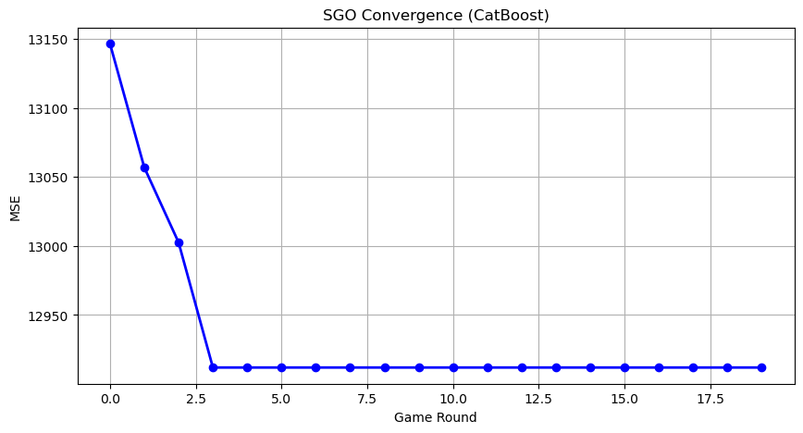

Squid Game Optimizer completed successfully with MSE: 12911.9412

==================================================

Running PSH-Hyptrite...

==================================================

==================================================

=== PSH-HYPTRITE OPTIMIZATION ===

==================================================

[Initialization]

- Search points: 30

- Max iterations: 20

- Initial radius: 0.5 (adaptive)

- Hypersphere samples: 3 per point

- Search space: 176 features

- Target: Minimize MSE using CatBoost

[Optimization Progress]

Iter 20/20 | Best MSE: 13021.390952 | Radius: 0.0250

==================================================

=== OPTIMIZATION RESULTS ===

==================================================

▶ Best MSE achieved: 13021.390952

▶ Time elapsed: 1250.43 seconds

▶ Features selected: 102/176 (42.0% reduction)

▶ Selected features (with weights):

1. District (weight: 0.835)

2. m² (Gross) (weight: 0.780)

3. Building Age (weight: 0.935)

4. Floor location (weight: 0.735)

5. Number of floors (weight: 0.856)

6. Heating (weight: 0.849)

7. Available for Loan (weight: 0.514)

8. From who (weight: 0.823)

9. Swap (weight: 0.591)

10. Front West (weight: 0.805)

11. Smart House (weight: 0.999)

12. Alarm (Thief) (weight: 0.718)

13. Alaturka Toilet (weight: 0.810)

14. Barbecue (weight: 0.867)

15. Household appliances (weight: 0.887)

16. Painted (weight: 0.690)

17. Refrigerator (weight: 0.667)

18. Shower (weight: 1.000)

19. Fiber Internet (weight: 0.506)

20. On (weight: 0.538)

21. Intercom System (weight: 0.786)

22. Insulating glass (weight: 0.992)

23. Air conditioning (weight: 0.617)

24. Tub (weight: 0.578)

25. Kitchen (Built-in) (weight: 0.508)

26. PVC Joinery (weight: 0.724)

27. Parquet Floor (weight: 0.555)

28. Set Top Cooker (weight: 0.742)

29. Spot Lighting (weight: 0.588)

30. Terrace (weight: 0.895)

31. Thermosiphon (weight: 0.961)

32. Face Recognition & Fingerprint (weight: 0.645)

33. Washing machine (weight: 0.809)

34. Laundry room (weight: 0.980)

35. Steel door (weight: 0.926)

36. Water heater (weight: 0.646)

37. Fireplace (weight: 0.993)

38. Elevator.1 (weight: 0.772)

39. Steam room (weight: 0.636)

40. Bath (weight: 0.586)

41. Booster (weight: 0.612)

42. Thermal Insulation (weight: 0.680)

43. Generator (weight: 0.602)

44. Cable TV (weight: 0.955)

45. Closed Garage (weight: 0.863)

46. Water tank (weight: 0.509)

47. Satellite (weight: 0.662)

48. Fire escape (weight: 0.564)

49. Swimming Pool (Open) (weight: 0.654)

50. Parking Lot (weight: 0.674)

51. Elevator.2 (weight: 0.862)

52. Bathroom (weight: 0.949)

53. Wide Corridor (weight: 0.750)

54. Entrance / Ramp (weight: 0.595)

55. Stairs (weight: 0.849)

56. Room door (weight: 0.583)

57. Park (weight: 0.550)

58. Socket / Electric Switch (weight: 0.990)

59. Toilet (weight: 0.974)

60. Mosque (weight: 0.511)

61. Cemevi (weight: 0.852)

62. Next to sea shore (weight: 0.907)

63. Amusement center (weight: 0.952)

64. Fair (weight: 0.833)

65. Hospital (weight: 0.527)

66. Synagogue (weight: 0.803)

67. The church (weight: 0.669)

68. Market (weight: 0.823)

69. Unirsity (weight: 0.819)

70. Primary School-Secondary School (weight: 0.718)

71. Fire Department (weight: 1.000)

72. Town center (weight: 0.850)

73. Eurasia Tunnel (weight: 0.636)

74. Bosphorus Bridges (weight: 1.000)

75. Filled (weight: 0.531)

76. E-5 (weight: 0.583)

77. Airport (weight: 0.956)

78. Marmaray (weight: 0.977)

79. Metro (weight: 0.828)

80. Minibus (weight: 0.596)

81. Bus stop (weight: 0.757)

82. Coast (weight: 0.788)

83. Railway station (weight: 0.741)

84. Trolley bus (weight: 0.917)

85. Scaffolding (weight: 0.598)

86. Throat (weight: 0.731)

87. Sea (weight: 0.919)

88. Lake (weight: 0.567)

89. Pool (weight: 0.625)

90. Park & ​​Green Area (weight: 0.584)

91. Mezzanine (weight: 1.000)

92. Mezzanine Duplex (weight: 0.771)

93. Garden Duplex (weight: 0.822)

94. Garden Floor (weight: 0.523)

95. Top floor (weight: 0.529)

96. Garage / Shop Top (weight: 0.889)

97. Entrance floor (weight: 0.862)

98. Floor Duplex (weight: 0.991)

99. Private Entry (weight: 0.554)

100. Triplex (weight: 0.618)

101. Ground floor (weight: 0.502)

102. Roof Duplex (weight: 0.674)

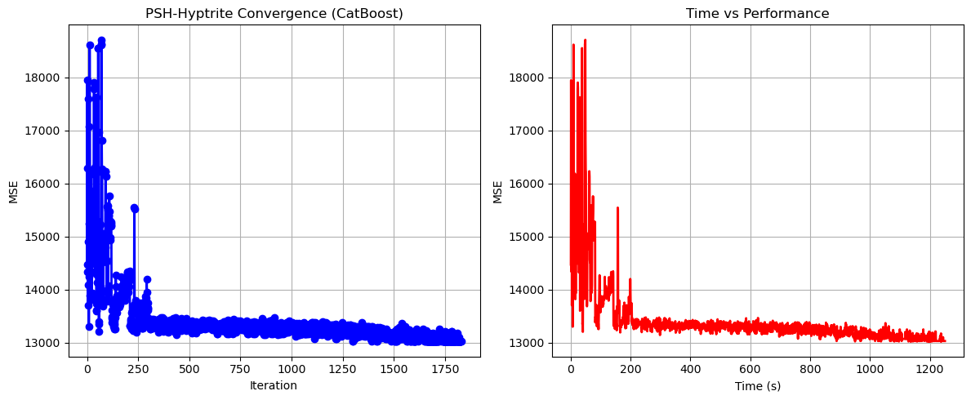

PSH-Hyptrite completed successfully with MSE: 13021.3910

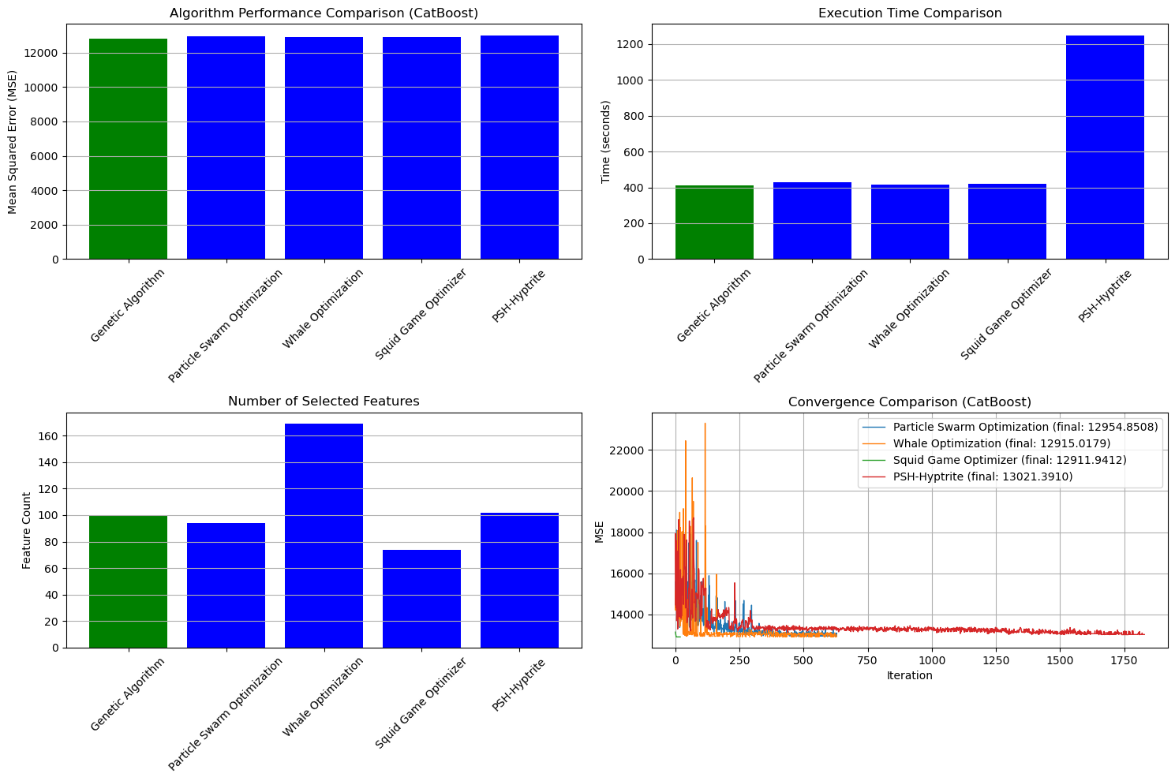

==================================================

FINAL RESULTS SUMMARY (Using CatBoost)

==================================================

🏆 Best Algorithm: Genetic Algorithm

📉 Best MSE Achieved: 12838.393577

⏱️ Execution Time: 409.59 seconds

🔢 Features Selected: 100

Selected Features:

1. District

2. Neighborhood

3. m² (Gross)

4. m² (Net)

5. Number of rooms

6. Building Age

7. Floor location

8. Heating

9. Number of bathrooms

10. Furnished

11. Using status

12. Available for Loan

13. From who

14. Swap

15. Front West

16. Front South

17. Alarm (Thief)

18. Alaturka Toilet

19. American Door

20. Elevator

21. Painted

22. Refrigerator

23. Fiber Internet

24. Dressing room

25. Intercom System

26. Insulating glass

27. Air conditioning

28. Tub

29. Laminate Floor

30. Marley

31. Furniture

32. Kitchen (Built-in)

33. Kitchen (Laminate)

34. PVC Joinery

35. Blinds

36. Set Top Cooker

37. Spot Lighting

38. Thermosiphon

39. Cloakroom

40. Wi-Fi

41. Face Recognition & Fingerprint

42. Washing machine

43. Laundry room

44. Water heater

45. Fireplace

46. Elevator.1

47. Security

48. Bath

49. Booster

50. Thermal Insulation

51. Generator

52. Cable TV

53. Closed Garage

54. Playground

55. Sports Area

56. Water tank

57. Tennis court

58. Satellite

59. Fire escape

60. Swimming Pool (Open)

61. Swimming Pool (Indoor)

62. Parking Lot

63. Bathroom

64. Wide Corridor

65. Entrance / Ramp

66. Kitchen

67. Handle / Railing

68. municipality

69. Cemevi

70. Next to sea shore

71. Fair

72. Hospital

73. Synagogue

74. Park.1

75. Gym

76. Unirsity

77. Highway

78. Bosphorus Bridges

79. Sea bus

80. Filled

81. Marmaray

82. Minibus

83. Bus stop

84. Coast

85. Tram

86. Railway station

87. Trolley bus

88. Scaffolding

89. Lake

90. Pool

91. City

92. Mezzanine Duplex

93. Garden Duplex

94. Garden Floor

95. Top floor

96. Entrance floor

97. Floor Duplex

98. Private Entry

99. Rerse Duplex

100. Roof Duplex